A Study on Kinetic Art as Synesthesia Visualization by Music Waveform

WonUng Jeong, SeHwa Kim

Graduate School of DongSeo University
Busan, South Korea
de-coder@naver.com
cvetlana@empal.com

Abstract

This study proposes music experience through listening, seeing—the two most fundamental ways—, and synesthesia by data visualization. To visualize music in synesthesia, the three elements—rhythm, harmony, and melody—of music and the information of the sound vibration of waveform in music are matched in terms of kinetic art to connect the visual meaning of information. Since the existing waveform visualization method is linear, this study aims to experience music synesthetically as a product of visualized kinetic art.
Keywords-component; waveform; kinetic art; visualization;

I. Introduction

A. Background
Music we encounter every day is a type of art expressing a thought or emotion through voice or instrument by combining and harmonizing beats, melody, and voice in many forms. A sound means a sound wave formed by vibration and is in a form of physical movement. We call this a waveform, which exists in different shapes in music that is based on sound, and thus the different characteristics of each music type can be identified. Waveform according to the change of time can deliver a non-verbal message since it is a movement including the progress of time unlike static visual and verbal expression. Thus, it is at the contact point with the expression technique of kinetic art delivering a message through a movement, and that expressions can vary as a synesthetic sensory substitution through visuals.

B. Concept of Research
Examples of common waveform visualization while listening to music are in the form of equalizer which shows high and low pitch depending on the frequency range of music. Such visualization of waveform is made to provide numerical, quantitative information that the physical sound of music has, and does not deliver the emotions of music as an art. The concept of this study is to examine the concept of kinetic form in terms of data visualization, to apply waveforms including the kinetic property of auditory waves on kinetic art where kinesis is important. This study is conducted in the order of: 1) Review of preceding studies on the extraction of visualization data; and 2) Study on the visualization of waveforms for kinetic art.
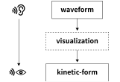
Fig. 1 Concept of Research

II. Related Research

A. Components of Music
Music largely consists of three elements: rhythm, harmony, melody, which are composed organically. “Rhythm is the time order of notes as they progress sequentially, and the most fundamental element of music. Two or more notes played at the same time are called a chord, and a harmony is a system of the connection of chords. The 19th century Romanticism emphasized on the character, feeling, and individuality that each chord had. Melody is the horizontal combination of notes with different pitch and length, and small melody units come together to create an overall flow.” [1]. That is, melody plays the leading role in consisting music while rhythm and harmony act in the background or mood to highlight the melody.

B. Concept of Waveform
A waveform is a sound wave with undulation in the shape or form of a signal which is like a moving wave, in a physical medium or abstract expression.
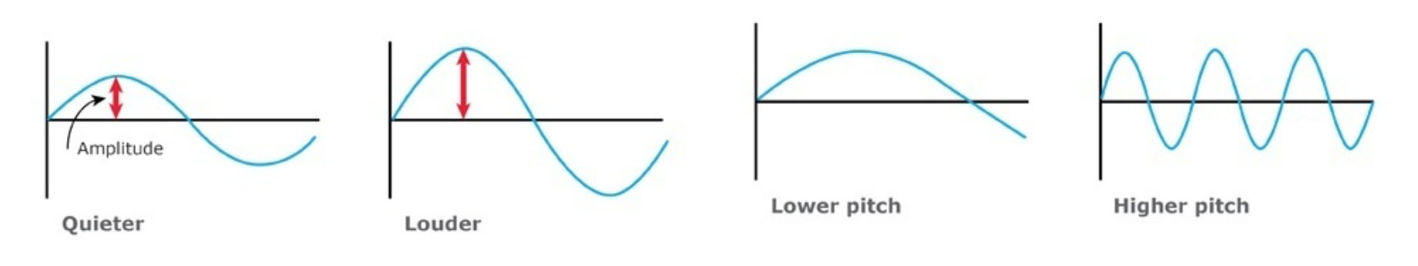
Fig. 2 Pitch and Volume in Waveform [2]
When the vibration information of sound is listed according to the direction of time progress, sound can be visualized in a quantitative waveform. On the y-axis, our ears feel that a sound is loud as the amplitude is high, and such size of sound is called volume. Such amplitude includes a number of vibrations, which is called frequency to show how many times a phenomenon occurs regularly within a unit of time. It is marked as Hz according to the international unit system, and 1Hz is interpreted a regular phenomenon occurs once per second. On the x-axis, the denser the vibrations are, the higher the notes feel, and such height of notes is called pitch.
Through the fluctuation of sound vibration, its volume and pitch can be visualized and the characteristics of each sound can also be identified. As in the commercialization of music fingerprint technology that provides music search service or protects music copyright by analyzing the quantitative sound information of music, waveform information is used to find the characteristics of each sound.

C. Kinetic Rhythm of Waveform
It is necessary to understand the concept of kinetic art to observe the kinesis of waveform in terms of kinetic art. The term kinetic art originates from Greek words kinesis which means movement and kinetic which means mobile; thus the term is used to refer to art based on movements [3].
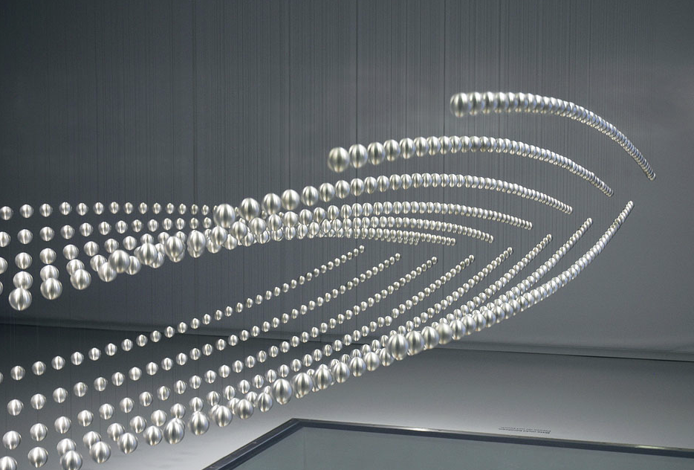
Fig. 3 Kinetic Sculpture- Shapes of things to come, art + com, 2008.
Kinetic art is an abstract, 4D art with the concept of time consisting of time, movement, and contingency [3]. In kinetic art, actual kinetics must occur whether it is a movement of a work of formative art or is a movement of the audience.
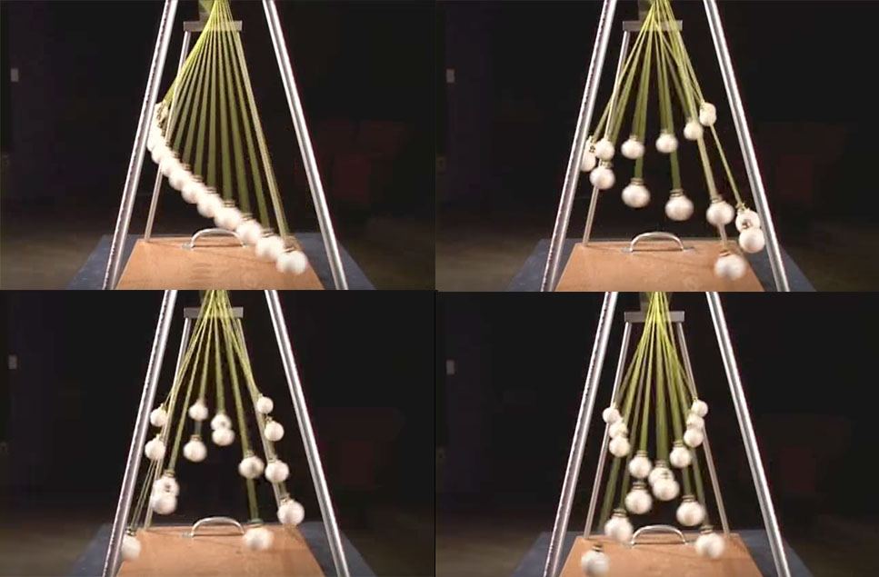
Fig. 4 Pendulum Waves, Harvard Natural Sciences Lecture Demonstrations, 2010.
“Pendulum Waves” is an example showing the 3 elements of kinetic art. Several pendulums are arranged in the gradual ascending order of length and movement, creating a random pattern as the time and energy of gravity pass. The pattern is a visualization of the kinetics rhythm created until all gravity energy is exhausted, and such rhythm is shown when the volume of vibration increases or decreases in a consistent waveform pattern in music. That is, the volume and pitch of kinetics through the sound vibration in waveform have the same width as the length and movement of pendulum in “Pendulum Waves”, and the rhythm of kinetics can be expressed formatively through a waveform in kinetic art.

D. Tone of Waveform
Visible ray, which shows all objects in colors, means the wavelength visible to human eyes among electromagnetic waves, and audibility frequency is a frequency range that human can hear. When these two ranges are in the relation of correspondence by relative values, the visible ray color of wavelength mirrors the frequency of a sound can be known.
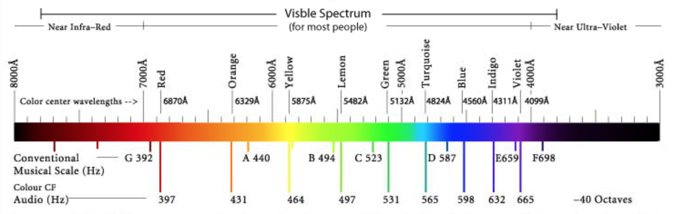
Fig. 5 Corresponding colour of each note after transposition (Fiorenza, 2010) [4]
The method of approaching the relationship of color and sound synesthetically is called Sonochromatism, which is a neurological phenomenon of perceiving color as a sound. It is a combined word of Latin: sono- (sound) + Greek: chromat (color) + Greek: -optia (see) [3]. This term was created by visual artist Neil Harrison, who was born with total color blindness, to differentiate his color experience from people with color sense or color-sound sympathy [4].
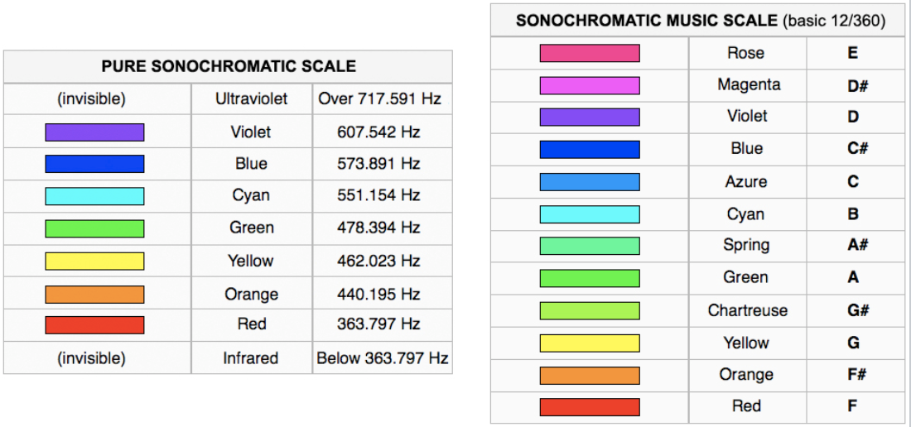
Fig. 6 The Harbisson's Sonochromatic Music Scale [5].

‘The Harbisson's Sonochromatic Music Scale (e.g., “Fig. 6”)’ organizes the wavelength of value that mirrors the frequency of a scale, showing the wavelength color that matches each scale. Here, the scale means ‘Do-Re-Mi-Fa-Sol-La-Ti’, and is marked in ‘CDEFGAB’. The consecutive circular structure of such scale is called the Circle of Fifths; when a scale progresses clockwise from a certain key, it returns to the original key in the end. The Circle of Fifths also shows the relationship of tones that match in harmony.
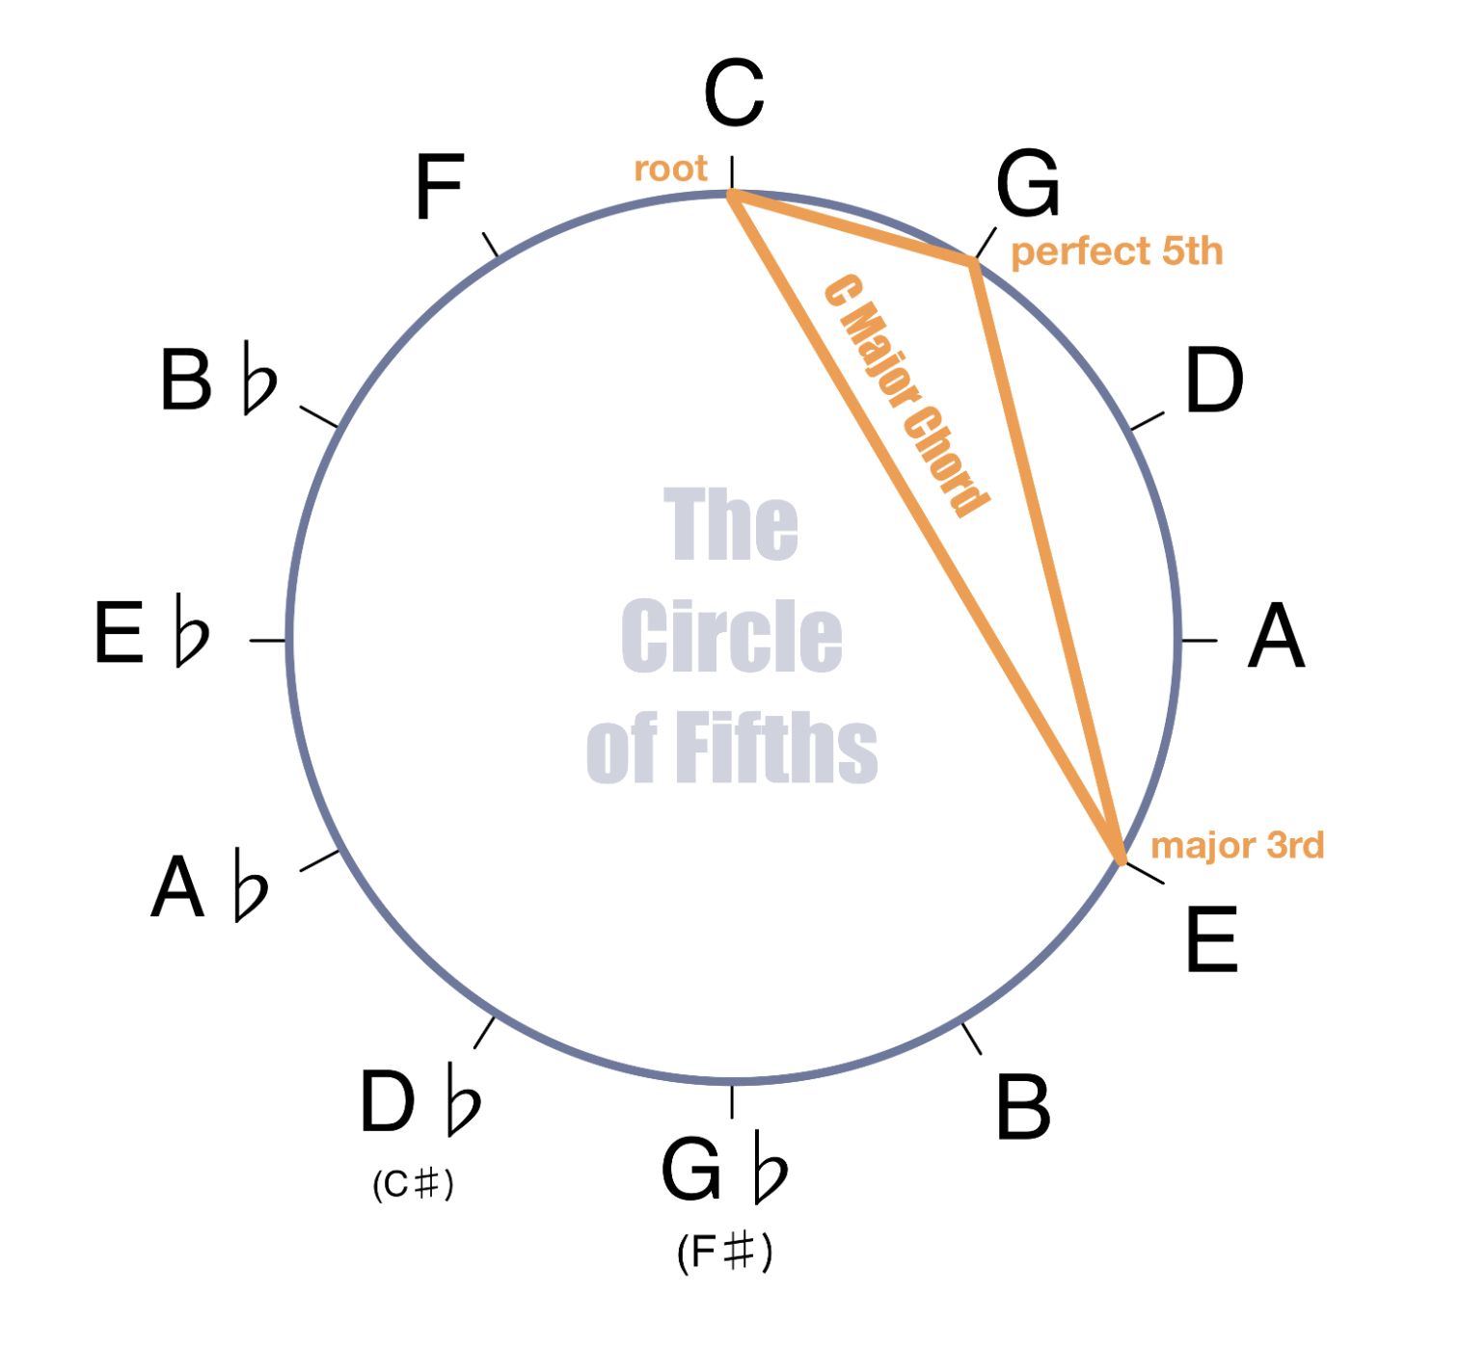
Fig. 7 Circle of Fifths- key C (left) [6] &
Munsell color system (right) [7].
According to Munsell’s perspective on the complementary color of hue circle, the concept of chord can be understood as matching with a certain color. The term “chord” originated from medieval English “cord”, and is a shortened expression of “accord” which means “harmonious sound” [8]. Harmony is the arrangement of chords in a horizontal time-axis and is a main element of music to express a mood.
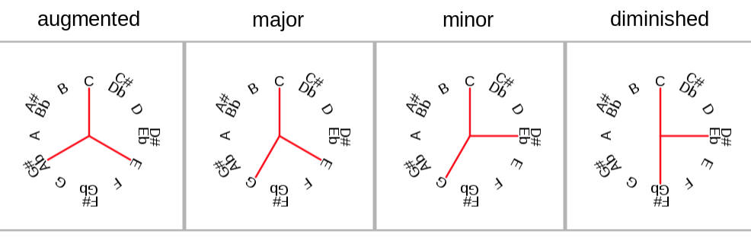
Fig. 8 Triadic chord examples (key of C) [9].
By the classical era, chords were created through natural harmonics based on triad that emphasized harmony [1]. The horizontal arrangement of the scales of each chord satisfy the basic conditions of harmony, creating the melody of music. Triadic chord examples (key of C) (e.g., “Fig. 8”) shows augmented triad, major triad, diminished triad, and minor triad from left on the C scale, showing the properties of triads.
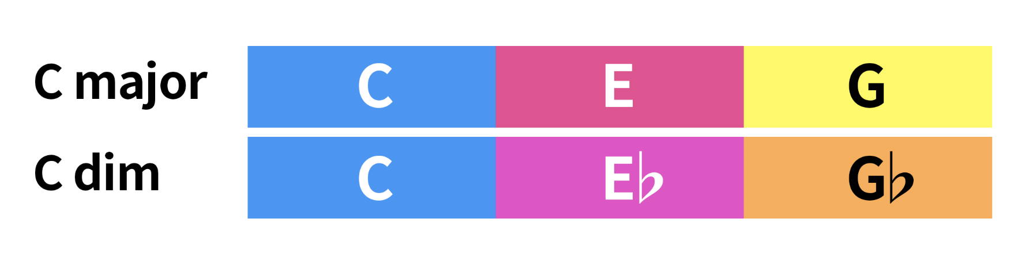
Fig. 9 Different Color Tone in C Chords
Since adding a sharp or flat to a note affects the tone in all triads except the major triad, it must be considered during the synesthesia colorization of harmony.

III. Design and Development

A. Formalization of the Kinetic Rhythm of Waveform
In a waveform, volume and pitch correspond to the x and y axes of physical locations in a kinetic-form. The volume of vertical amplitude means the degree of a sound volume, and it influences the vertical kinetic rhythm in kinetic art. The interval of horizontal amplitude means the pitch of a sound, thus influencing the horizontal rhythm among movements in kinetic art.
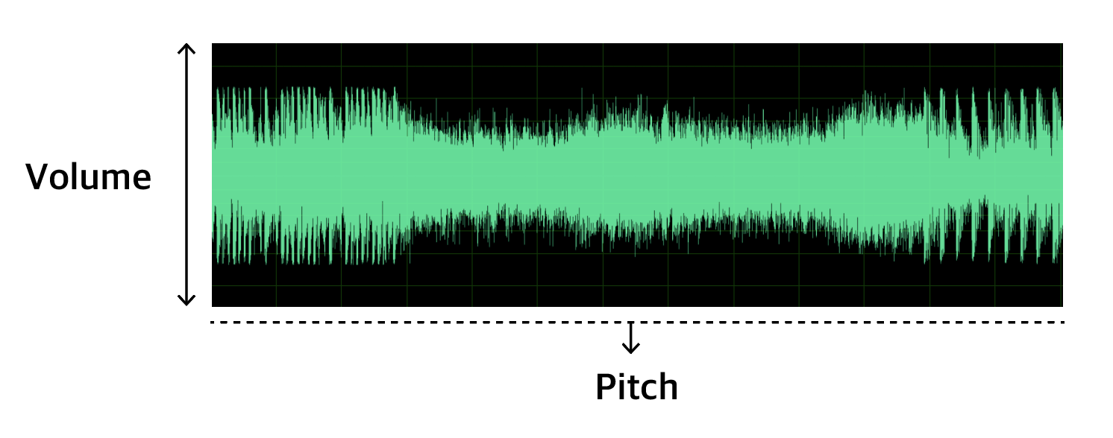
Fig.10 Analyze Waveform of ‘Latch (2:14- 2:50)- Disclosure’
That is, the higher the volume of waveform is, the heavier impression of the huge vertical kinetics can be delivered like the volume of high waves. Lower pitches with wide pitch intervals of waveform create gradual horizontal curves, and can deliver an impression of calm waves.
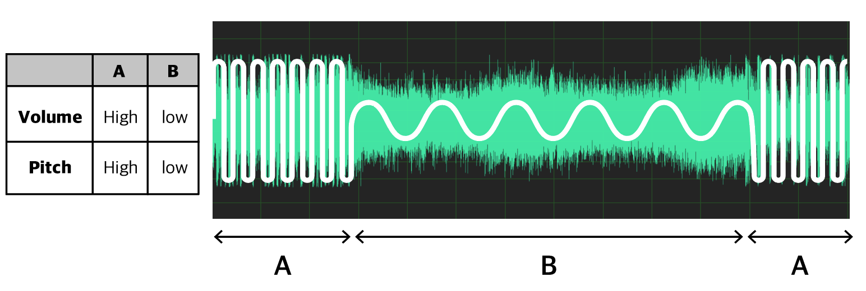
Fig. 11 Normalize Rhythm

Normalize Rhythm (e.g., “Fig. 11”) is a simplification to deliver a message in a clear pattern in kinetic art, by simplifying horizontal and vertical kinetic rhythms through the volume and pitch of volume. A section shows a very huge volume and high pitch, while B section shows a rhythm with a relatively smaller volume and lower pitch compared to A.

B. Visualization of Tone in Waveform
While a pitch in waveform is used to perceive the pitch of a note, it is also used to extract the frequency of scale Adam M. Stark (2009) proposed a more accurate way than the existing way of extracting chords through wavelength frequency.
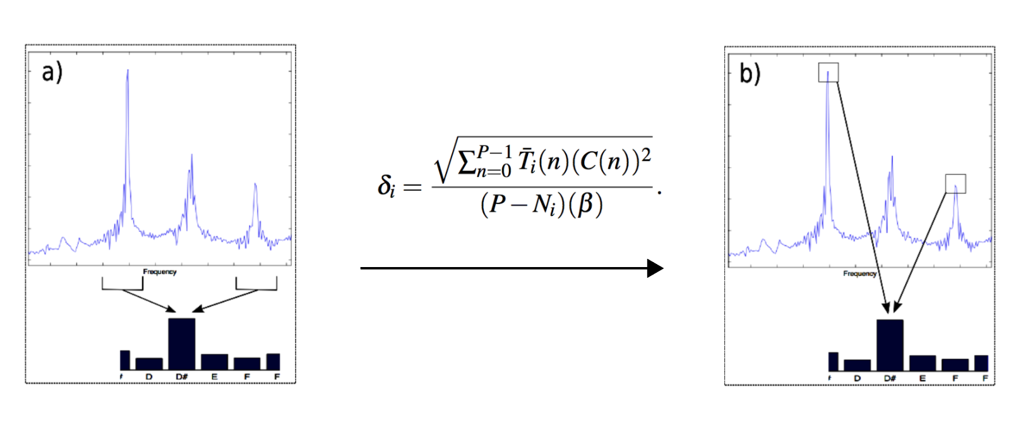
Fig. 11 Detection Chord, Adam M. Stark [10]

While the frequency intervals of a certain wavelength were analyzed and matched with the frequency of the most similar chord in the existing method, Adam Stark proposed analyzing the chord frequency in a section with the richest amplitudes in the rhythms of waveform.
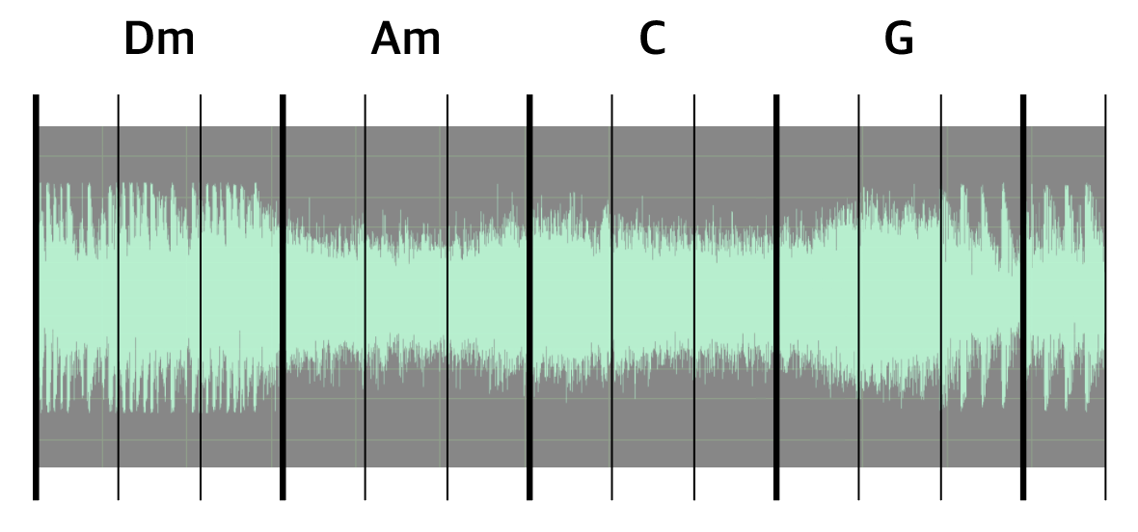
Fig. 12 Visualization of Beats and Chord

Visualization of Beats and Chord (e.g., “Fig. 12”) shows that waveforms were divided into the beat unit of music and the chords of each section were extracted. A chord includes multiple horizontal scales, and its melody that can be generated through the music beat can be conjectured through the Circle of Fifths.
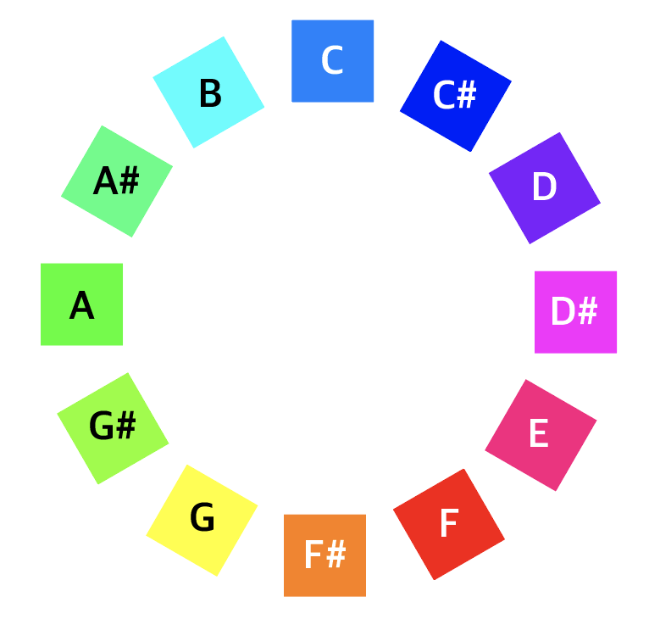
Fig. 13 Circle of Fifths as Harbisson's Sonochromatic Music Scale
Circle of fifths as Harbisson's Sonochromatic Music Scale (“Fig. 13”) is a structure map of Harbisson's Sonochromatic Music Scale and the Circle of Fifths to visualize the tone of melody that the chord includes. For example, D minor code consists of D F A as a basic third chord scale. That is, D F A scale forms a melody in the beat where Dm code (Chord) is allocated, which can colorize the tone of minor code when connected to the colors.
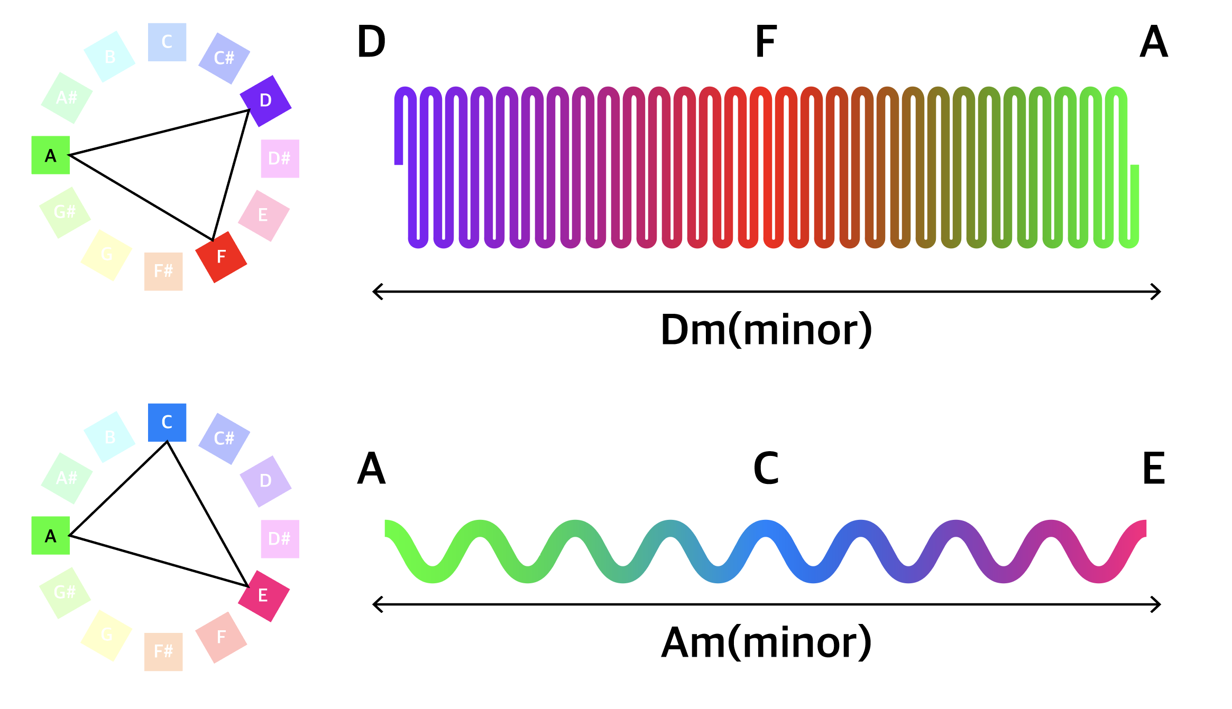
Fig. 14 Example of Kinetic-form Visualization

Example Kinetic-form Visualization (e.g., “Fig. 14”) is the visualization of harmony and melody into a tone in the kinetic-form and rhythm to be applied to kinetic art.

IV. Simulation Kinetic-Form

The simulation of a final kinetic-form is as follows. The example music is Latch of Disclosure, and the selected section was the chord progression of Dm and Am between 2:14 ~ 2:50. Based on the example Kinetic-form Visualization (e.g., “Fig. 14”), the variables of id-object index, count-count of object, and t-project time for the formula of movements to express as in “sin ( ( (id/count)+t)*360.0)”. The colors were used in gradations and the simulation was created around the point of code change in each section of the music.

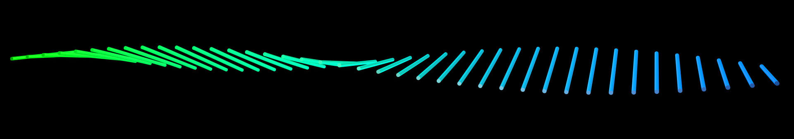
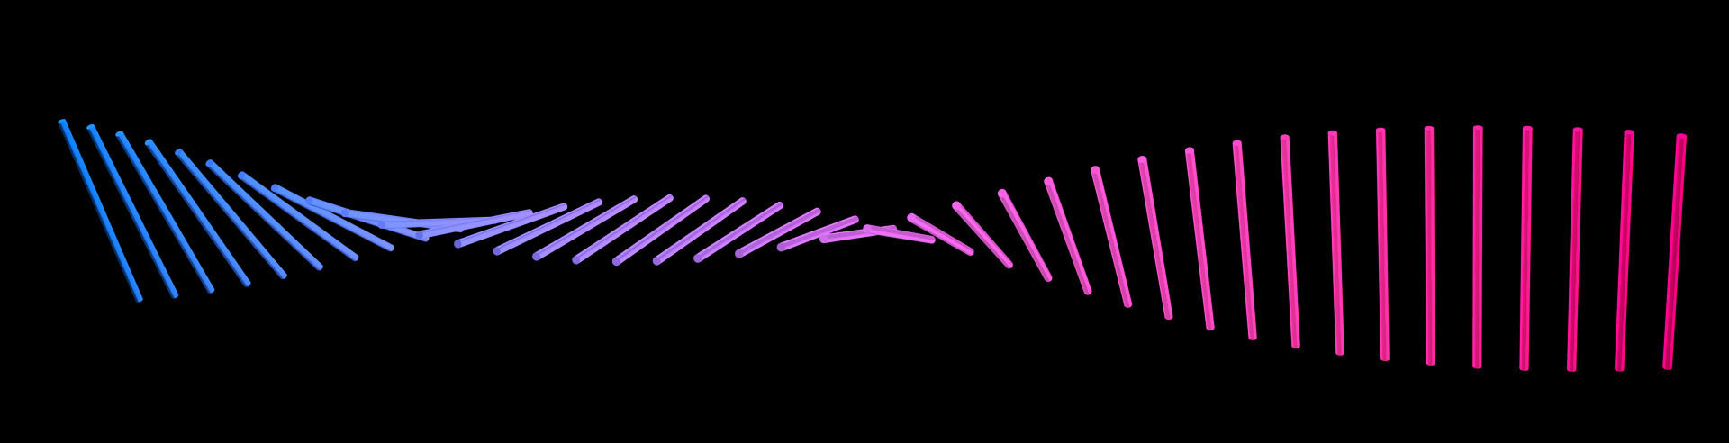
(1) Low Pitch, Low Volume, A chord to C chord
(2) Low Pitch, High Volume, C chord to E chord
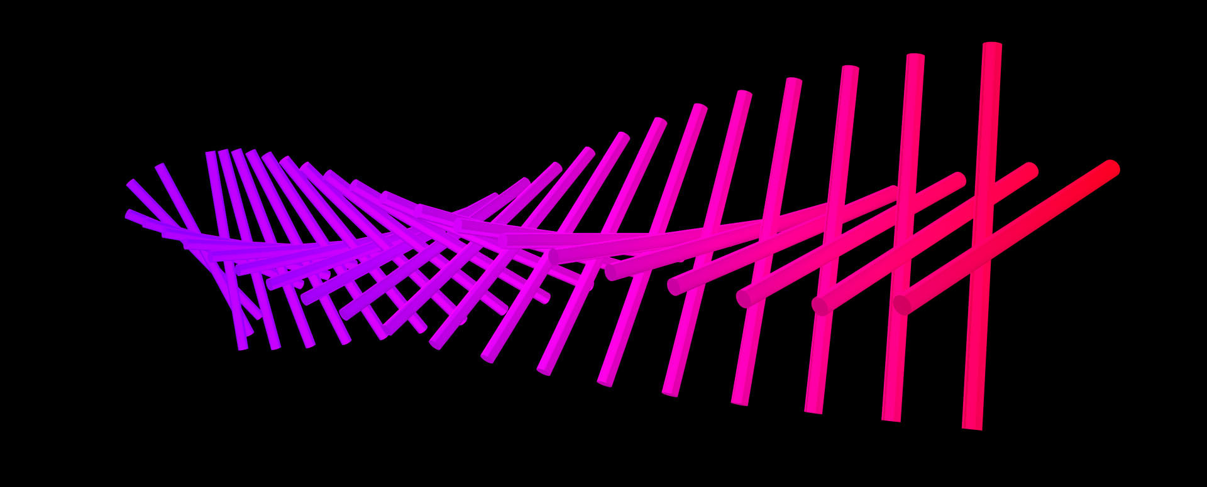
(3) High Pitch, High Volume, D chord to F chord
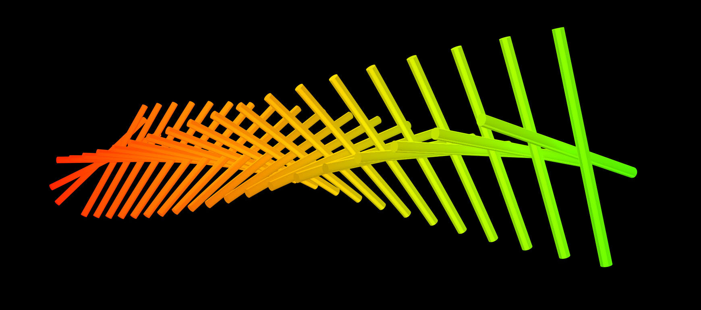
(4) High Pitch, High Volume, F chord to A chord
V. Conclusion

A waveform in music includes physical kinetic energy, which contains the information of an emotion the music seeks to deliver. Through the vibration width and interval of wavelength, this study extracted the information of rhythm, melody, and harmony which are the 3 basic elements of music, and proposed synesthesia visualization method through kinetic art. By suggesting the connecting points of the semantic component of two art genres—music and kinetic art—for the qualitative information of music, we can expect to have the expansion of kinetic art expression as well as the diversification of the data visualization approach.

Acknowledgment

This research was supported by BK21plus Level-up Project for Marine design team in Dongseo University.

References

[1] Theory of Music, Hyeon-nam Shin, Kyohaksa, 2014.
[2] The University of Waikato, www.sciencelearn.org.nz, 2011.
[3] A Study on the Contingent Expression of Interactive Kinetic Art, Kim, Jeong hyun, Ewha Womans University, 2003.
[4] Fiorenza, www.lunarplanner.com/Harmonics/planetary-harmonics.html, 2010.
[5] https://en.wikipedia.org/wiki/Sonochromatism
[6] http://musl.ink/c5ths
[7] https://en.wikipedia.org/wiki/Munsell_color_system
[8] "Chord", Oxford Dictionaries.
[9] https://en.wikipedia.org/wiki/Chord_ (music)
[10] "Real-Time Chord Recognition For Live Performance", A. M. Stark and M. D. Plumbley. In Proceedings of the 2009 International Computer Music Conference (ICMC 2009), Montreal, Canada, 16-21 August 2009.

